**Tugas Mandiri - 3**

Pengantar Sistem Digital

2022/2023 - 1

Petunjuk pengerjaan:

* Kerjakan dengan tulisan tangan atau diketik.
* Tuliskan Nama, Kelas, dan NPM pada setiap lembar jawaban.
* Tuliskan penjelasan dari cara mendapatkan jawaban tersebut.
* Apabila ditulis tangan, hasil pekerjaan di scan / foto dan dimasukan ke dalam satu file berformat .pdf.
* Format nama file (tanpa tanda kurung) : **[KodeAsdos]_TM3_[Nama]_[NPM].pdf**.
* Tugas mandiri dikumpulkan Jumat, 7 Oktober 2022 pukul 17.00 pada slot yang sudah disediakan di SCELE.
* Jika **mengumpulkan telat sebelum pukul 23:59 pada hari yang sama**, akan dikenakan **penalti sebesar 50 poin**. Terlebih dari waktu tersebut, tugas mandiri **tidak akan dinilai**
* Jika perlu pembulatan, bulat ke atas pada digit ke-n! (Dalam kasus pembulatan biner, digit “terakhir” akan selalu 1)

1. (27 poin) Sederhanakan fungsi berikut menggunakan aljabar boolean, tulis hukum yang digunakan. Dan hitung banyak L, G, GN sebelum dan setelah simplifikasi.
   1. F(A,B,C,D) =

**Sebelum Simplifikasi**

Literal cost (L): 10

Gate input cost (G): 15

Gate input cost with NOTs (GN): 18

**Simplifikasi**

F(A,B,C,D) =

= Distributive Law

= Distributive Law

= Inverse Law

= Identity Law

= Distributive Law

= ) Absorption Law

**Sesudah Simplifikasi**

Literal cost (L): 5

Gate input cost (G): 8

Gate input cost with NOTs (GN): 9

* 1. F(A,B,C,D) =

**Sebelum Simplifikasi**

Literal cost (L): 7

Gate input cost (G): 11

Gate input cost with NOTs (GN): 14

**Simplifikasi**

F(A,B,C,D) =

= Distributive Law

= Distributive Law

= Idempotent Law

= Absorption Law

= Absorption Law

= Absorption Law

= Distributive Law

**Sesudah Simplifikasi**

Literal cost (L): 4

Gate input cost (G): 6

Gate input cost with NOTs (GN): 8

* 1. F(A,B,C,D) =

**Sebelum Simplifikasi**

Literal cost (L): 6

Gate input cost (G): 8

Gate input cost with NOTs (GN): 10

**Simplifikasi**

F(A,B,C,D) =

= Distributive Law

= Absorption Law

= Absorption Law

= Absorption Law

= Absorption Law

**Sesudah Simplifikasi**

Literal cost (L): 4

Gate input cost (G): 4

Gate input cost with NOTs (GN): 5

1. (27 poin) Optimalkan fungsi-fungsi berikut menggunakan K-Map dan cari bentuk paling sederhana dari SOP dan POS-nya.
   1. F(A,B,C,D) =Σm (0,2,4,5,6,10,12,13,14,15)

**K-Map:**

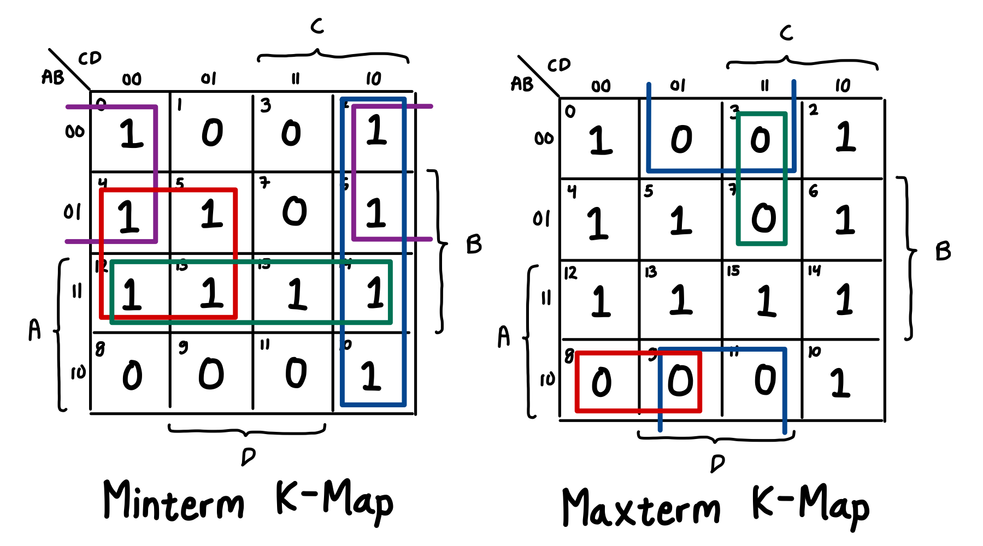

**SOP:** A’D’ + BC’ + AB + CD’

**POS:** (AB’C’ + B’D + A’CD)’ = (A’+B+C)(B+D’)(A+C’+D’)

* 1. F(A,B,C,D) =ΠM (1,2,3,5,6,7,8,9)

**K-Map:**

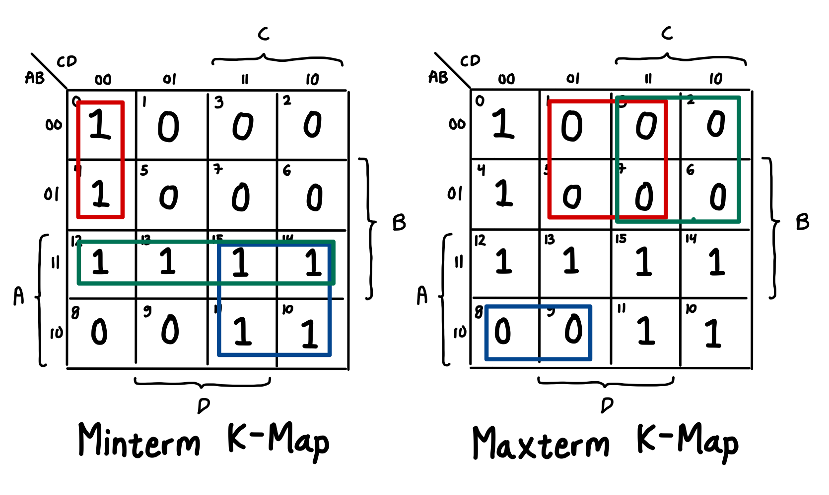

**SOP:** A’C’D’ + AB + AC

**POS:** (AB’C’ + A’D + A’C)’ = (A’+B+C)(A+D’)(A+C’)

* 1. F(A,B,C,D,E) = (

= ( Distributive Law

= Distributive Law

= Distributive Law

**K-Map:**

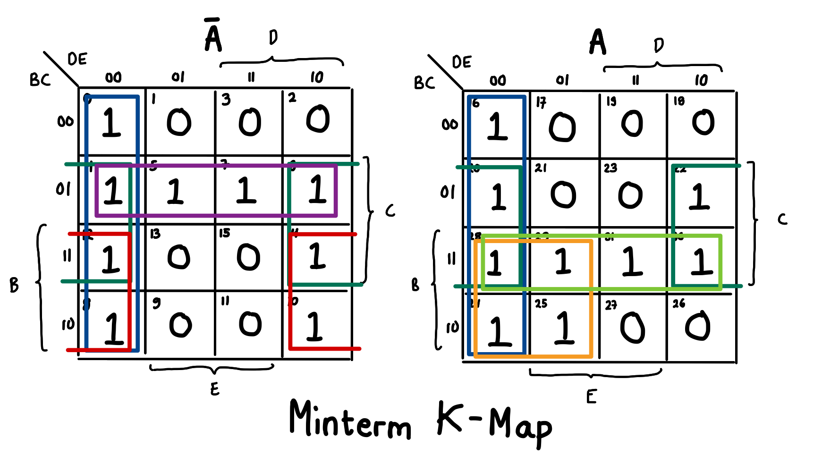

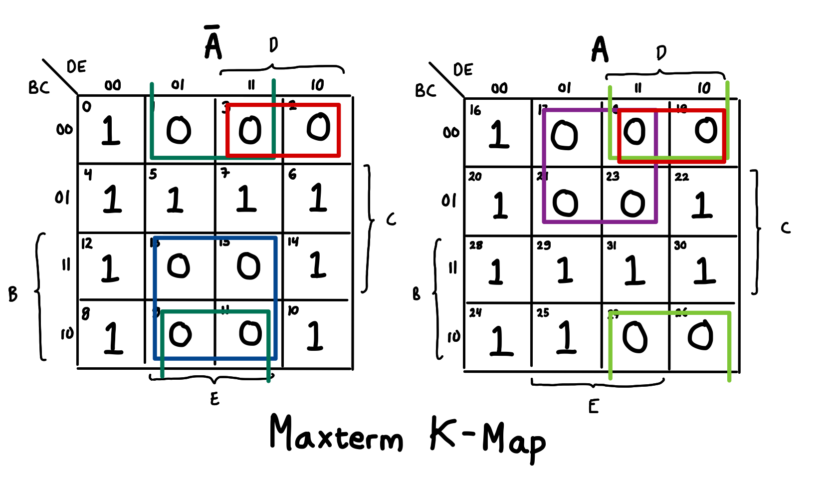

**SOP:** D’E’ + CE’ + A’BE’ + ABD’ + ABC + A’B’C

**POS:**

=

=

1. (18 poin) Optimalkan fungsi-fungsi berikut menggunakan aljabar boolean dan buat tabel kebenarannya.
   1. F(A,B,C,D) =

= Distributive Law

= Inverse Law

= Identity Law

**Truth Table:**

| **A** | **B** | **C** | **D** | **F** |
| --- | --- | --- | --- | --- |
| 0 | 0 | 0 | 0 | 0 |
| 0 | 0 | 0 | 1 | 1 |
| 0 | 0 | 1 | 0 | 0 |
| 0 | 0 | 1 | 1 | 0 |
| 0 | 1 | 0 | 0 | 1 |
| 0 | 1 | 0 | 1 | 1 |
| 0 | 1 | 1 | 0 | 0 |
| 0 | 1 | 1 | 1 | 0 |
| 1 | 0 | 0 | 0 | 1 |
| 1 | 0 | 0 | 1 | 1 |
| 1 | 0 | 1 | 0 | 1 |
| 1 | 0 | 1 | 1 | 1 |
| 1 | 1 | 0 | 0 | 1 |
| 1 | 1 | 0 | 1 | 1 |
| 1 | 1 | 1 | 0 | 0 |
| 1 | 1 | 1 | 1 | 0 |

* 1. F(A,B,C,D) =

= Distributive Law

= Absorption Law

= Distributive Law

= Distributive Law

= Absorption Law

= Distributive Law

= Distributive Law

= Absorption Law

= Distributive Law

= Consensus Law

= Distributive Law

**Truth Table:**

| **A** | **B** | **C** | **D** | **F** |
| --- | --- | --- | --- | --- |
| 0 | 0 | 0 | 0 | 0 |
| 0 | 0 | 0 | 1 | 1 |
| 0 | 0 | 1 | 0 | 0 |
| 0 | 0 | 1 | 1 | 1 |
| 0 | 1 | 0 | 0 | 0 |
| 0 | 1 | 0 | 1 | 1 |
| 0 | 1 | 1 | 0 | 0 |
| 0 | 1 | 1 | 1 | 0 |
| 1 | 0 | 0 | 0 | 1 |
| 1 | 0 | 0 | 1 | 1 |
| 1 | 0 | 1 | 0 | 1 |
| 1 | 0 | 1 | 1 | 1 |
| 1 | 1 | 0 | 0 | 1 |
| 1 | 1 | 0 | 1 | 1 |
| 1 | 1 | 1 | 0 | 1 |
| 1 | 1 | 1 | 1 | 0 |

1. (18 poin) Optimalkan fungsi-fungsi berikut menggunakan K-Map dan implementasikan dengan NOR atau NAND gate.
   1. F(A, B, C) = (gunakan NAND gate)

**Minterm K-Map:**

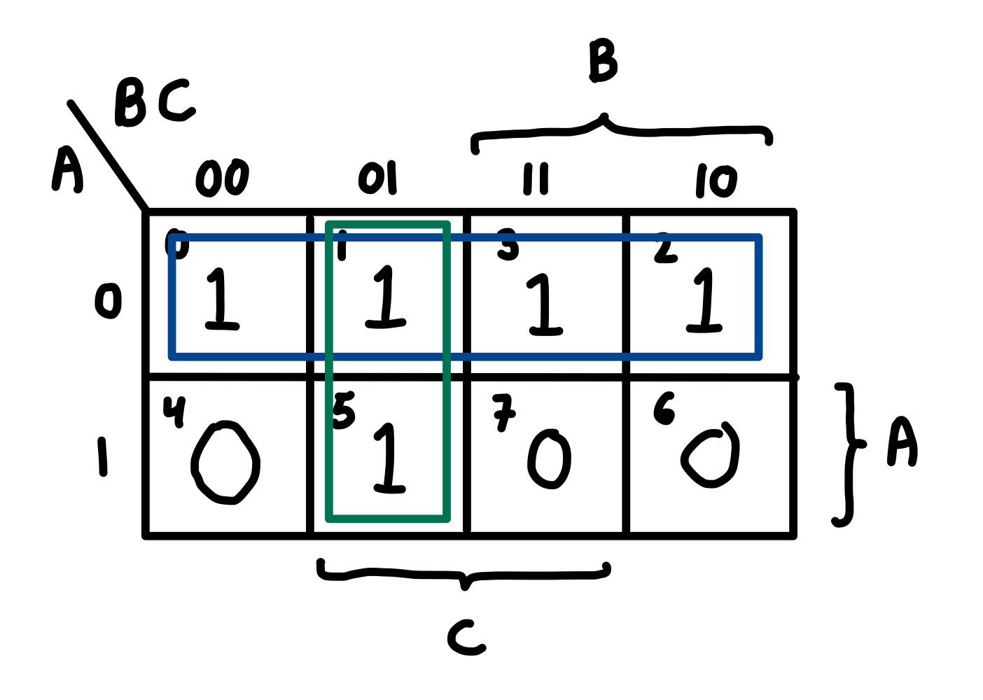

F(A, B, C) =

Dengan mengimplementasikan NAND gate:

F(A, B, C) = ((A’+B’C)’)’ = (A (B’C)’)’ = (A ((B B)’ C)’)’

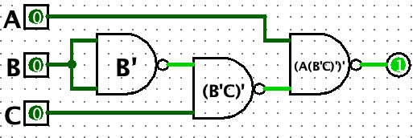

* 1. F(A, B, C) = (gunakan NOR gate)

F(A, B, C) = (A’B’)’ + (A’BC)’ + (AB’C’)’ + (ABC’)’

**Minterm K-Map:**

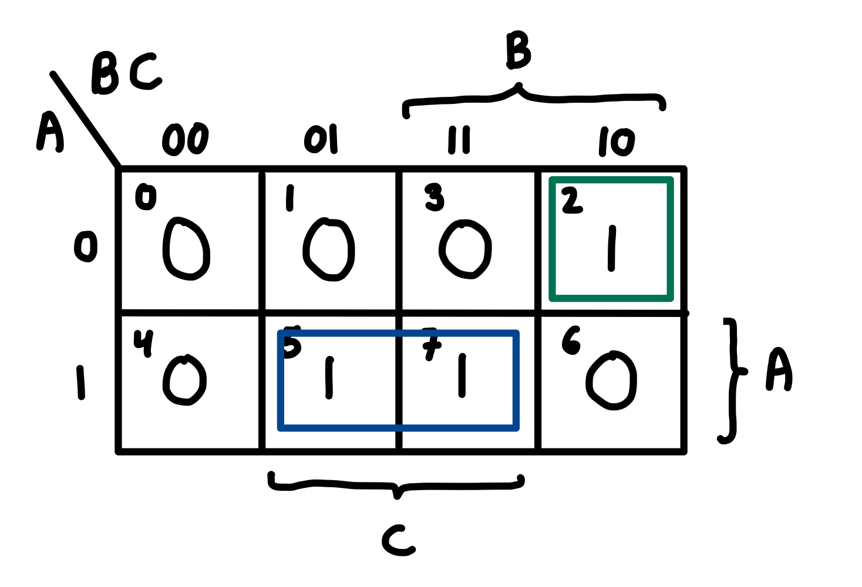

F(A, B, C) = =

F(A, B, C) = ((((A’ + C’)(A + B’ + C))’)’)’ = (((A’ + C’)’ + (A + B’ + C)’)’)’

= ((((A+A)’+(C+C)’)’ + (A + (B+B)’ + C)’)’)’

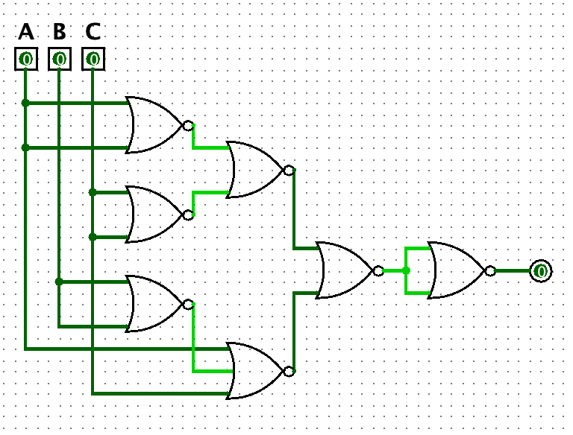

1. (10 poin) Buat K-Map dari tabel kebenaran dibawah (fungsi F(A, B, C, D, E)) dan tentukan semua *prime implicant* dan *essential prime implicant* nya!

| A | B | C | D | E | F |
| --- | --- | --- | --- | --- | --- |
| 0 | 0 | 0 | 0 | 0 | 0 |
| 0 | 0 | 0 | 0 | 1 | 0 |
| 0 | 0 | 0 | 1 | 0 | 1 |
| 0 | 0 | 0 | 1 | 1 | 1 |
| 0 | 0 | 1 | 0 | 0 | X |
| 0 | 0 | 1 | 0 | 1 | X |
| 0 | 0 | 1 | 1 | 0 | 1 |
| 0 | 0 | 1 | 1 | 1 | 1 |
| 0 | 1 | 0 | 0 | 0 | 0 |
| 0 | 1 | 0 | 0 | 1 | X |
| 0 | 1 | 0 | 1 | 0 | X |
| 0 | 1 | 0 | 1 | 1 | 0 |
| 0 | 1 | 1 | 0 | 0 | 1 |
| 0 | 1 | 1 | 0 | 1 | 0 |
| 0 | 1 | 1 | 1 | 0 | 1 |
| 0 | 1 | 1 | 1 | 1 | 0 |
| 1 | 0 | 0 | 0 | 0 | X |
| 1 | 0 | 0 | 0 | 1 | 1 |
| 1 | 0 | 0 | 1 | 0 | X |
| 1 | 0 | 0 | 1 | 1 | 0 |
| 1 | 0 | 1 | 0 | 0 | 1 |
| 1 | 0 | 1 | 0 | 1 | 1 |
| 1 | 0 | 1 | 1 | 0 | X |
| 1 | 0 | 1 | 1 | 1 | X |
| 1 | 1 | 0 | 0 | 0 | 0 |
| 1 | 1 | 0 | 0 | 1 | 1 |
| 1 | 1 | 0 | 1 | 0 | 0 |
| 1 | 1 | 0 | 1 | 1 | 1 |
| 1 | 1 | 1 | 0 | 0 | 1 |
| 1 | 1 | 1 | 0 | 1 | X |
| 1 | 1 | 1 | 1 | 0 | 1 |
| 1 | 1 | 1 | 1 | 1 | X |

